Simulation Descriptions :

- LDPC is the DVB-S2 LDPC, where I used the long FEC Mode (n = 64800). The supported rates in the standard are [1/4,1/3,2/5, 1/2, 3/5,2/3, 3/4, 4/5, 5/6, 8/9, 9/10]

For Encoding and Decoding of the LDPC I used the legacy matlab functions
comm.LDPCEncoder
comm.LDPCDecoder

Where the only parameters I configured where the parity check matrix $H$ (according to the standard matrices) and MaximumIterationCount (set to 70).
In case of hard decision (slicing after convolutional decoder) I also set the "Decision Method" property to "Hard Decision".

- Convolutional Codes were taken from the paper
"Rational Rate Punctured Convolutional Codes for Soft-Decision Viterbi Decoding" Irina E. Bocharova and Boris D. Kudryashov
For Encoding and Decoding I used the legacy matlab functions
comm.ConvolutionalEncoder
comm.APPDecoder

Where I configured the trellis according to the polynomials in the convolutional codes paper, and for the App Decoder I used the "Max*" decoding algorithm (True App appeared to have some weird results, maybe normalizations problem)
The LLRs for the App decoder where the channel output and calculated using the standard equation
$$LLR=\frac{4\sqrt{E_{b}}}{σ^{2}}⋅real\left(y\right)$$
- Between the Convolutional Code and LDPC I inserted simple block interleaver.

- I implemented the deletions by discarding bits after the LDPC Encoder, and insert zeros before the LDPC Decoder for the relevant LLRs.

- The Overall rate is the number of information bits, divided by the output length of the convolutional code – when I insert erasures the effective rate increases.

- $\frac{E_{b}}{N_{0}}$ counts for the Energy of the information bits – SNR is given by

$$SNR=10\log_{10}\left(\frac{E_{b}}{N_{0}}\right)+10\log_{10}\left(R^{effective}\right)+10\log_{10}\left(m\right)$$
Where $R^{effective}$ is the effective rate (the overall rate is higher when we insert deletions).
- I Implemented only the soft Decision For now (the hard decision results were bit confusing, I'll check for errors in my simulations)
- For coarse comparisons I took the BER of the plain vanilla DVB-S2 LDPC

Gaussian Capacity:
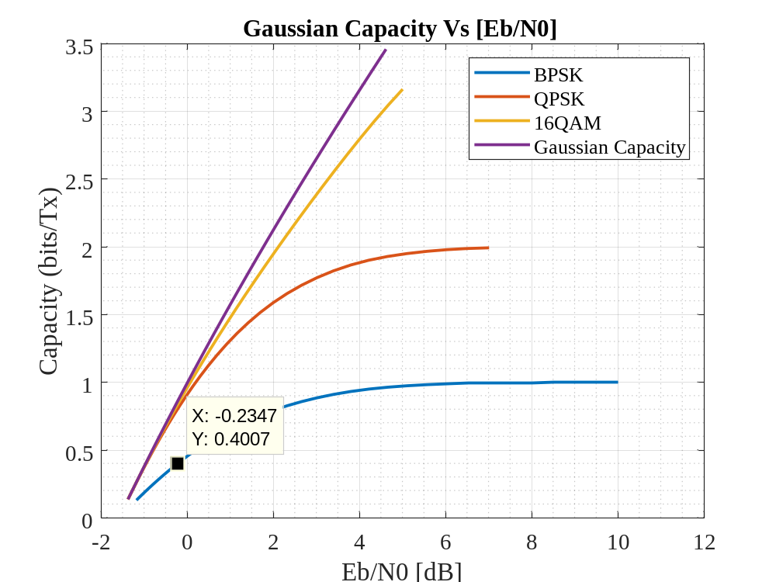

DVB-S2 LDPC Performance:
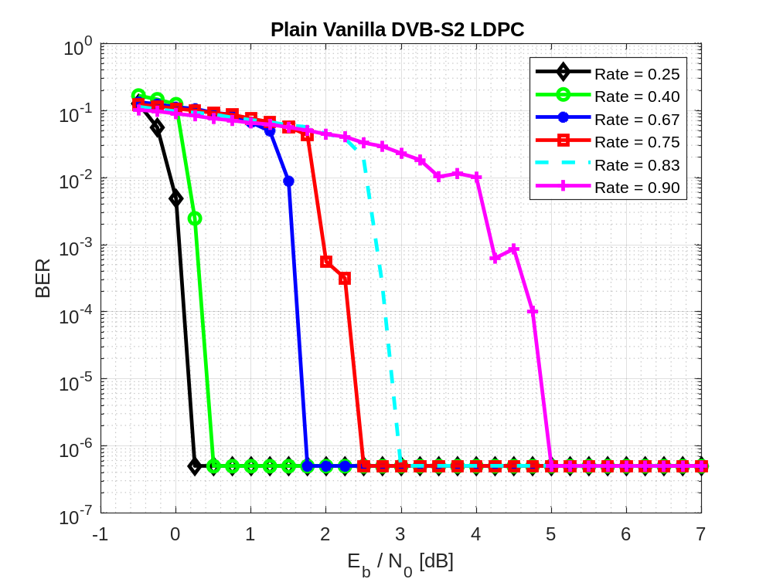
Results:
$R_{LDPC}=0.9$
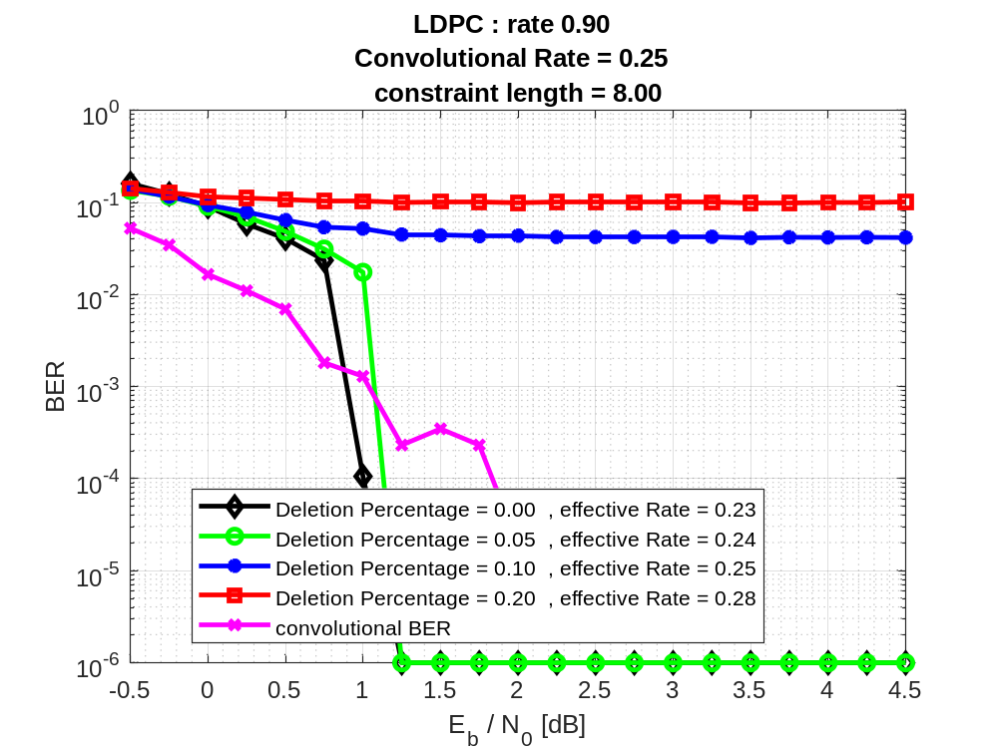
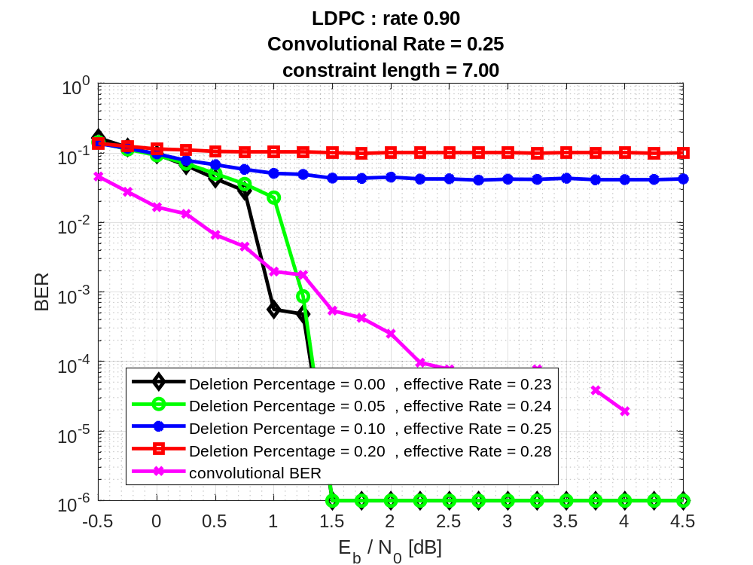
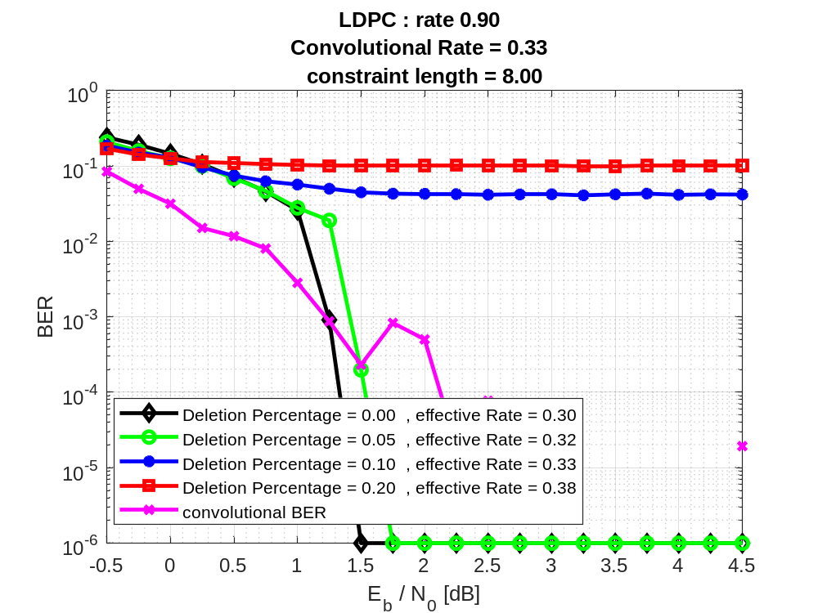
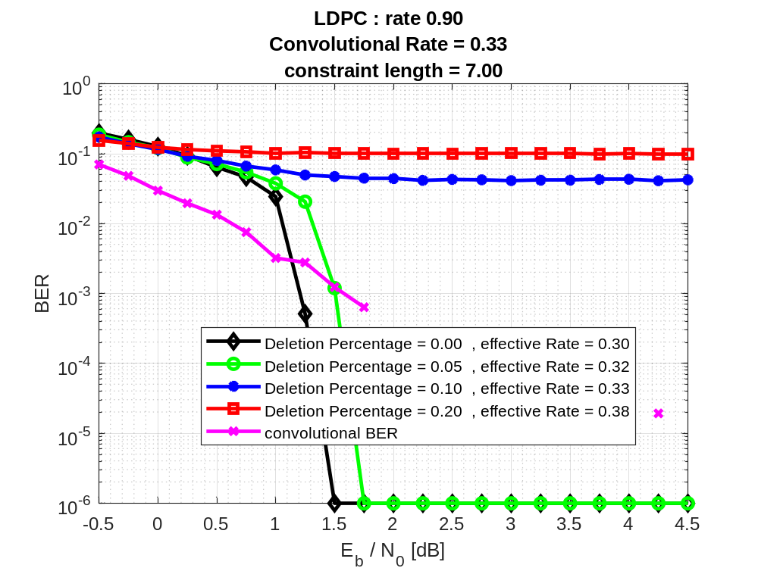
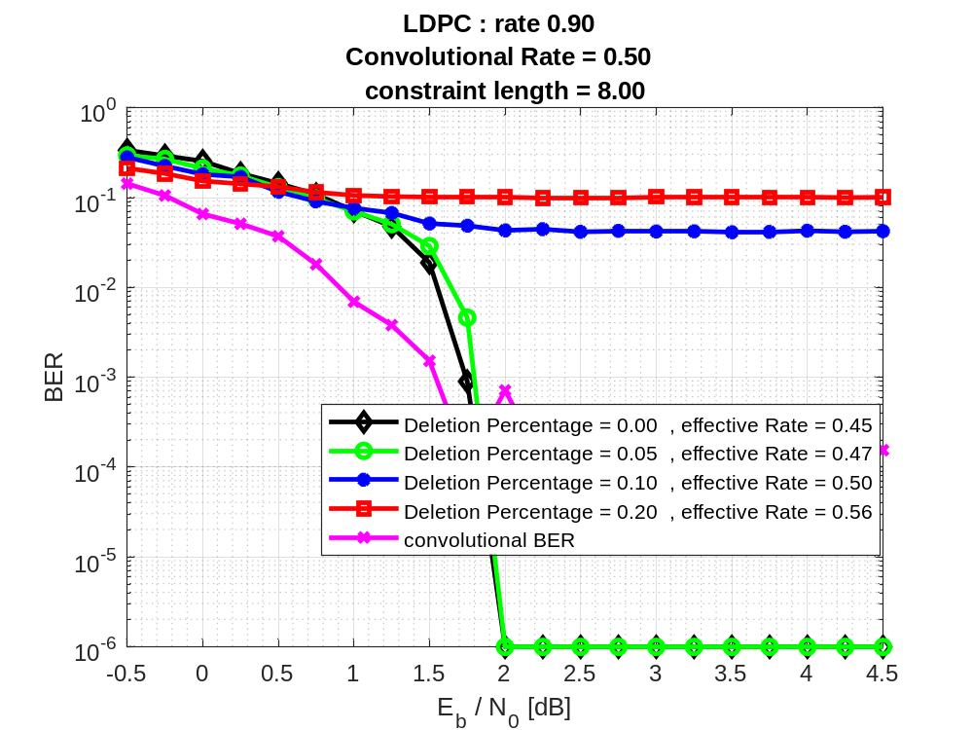
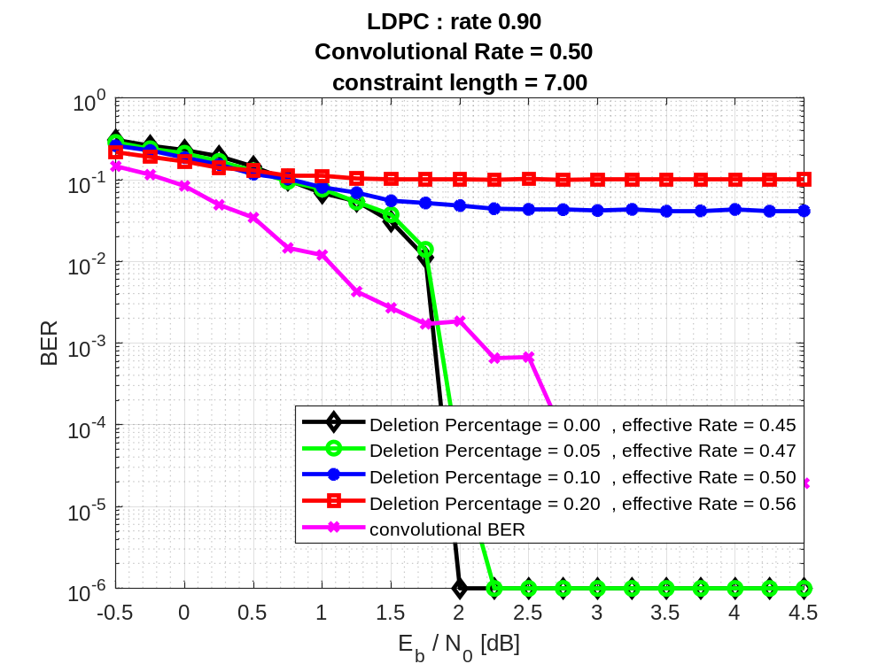

$R_{LDPC}=\frac{5}{6}$
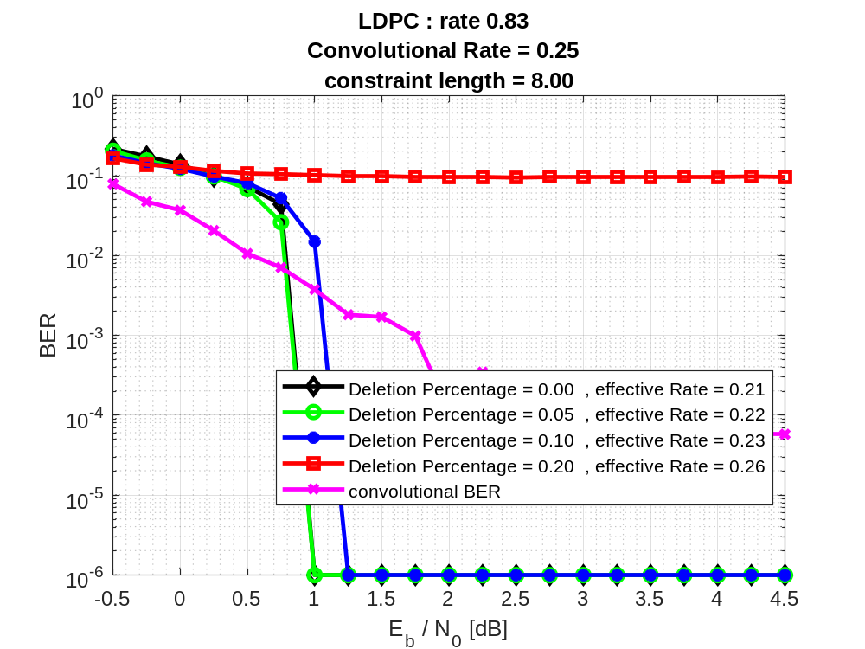
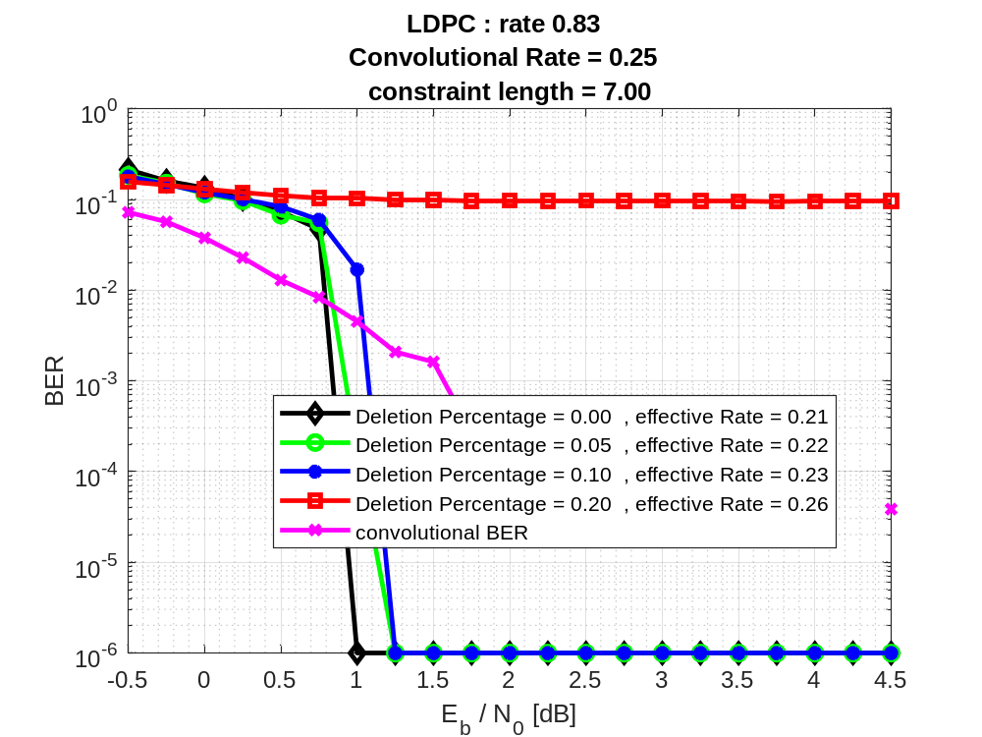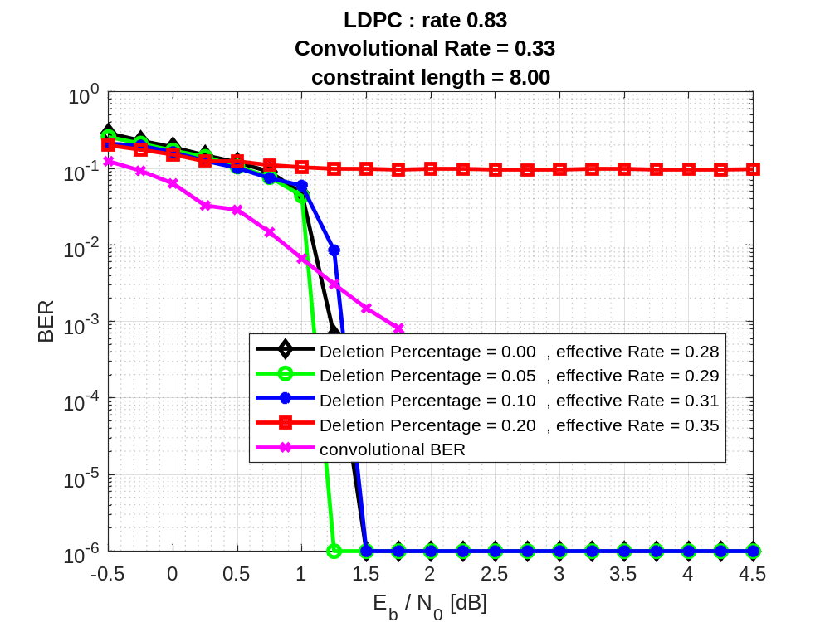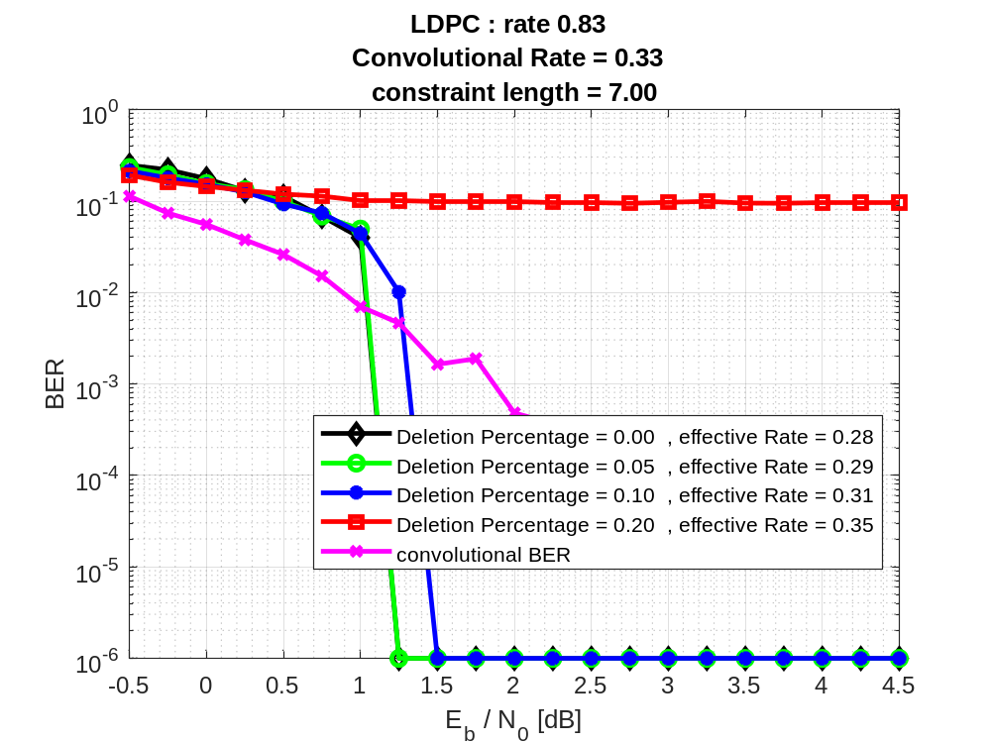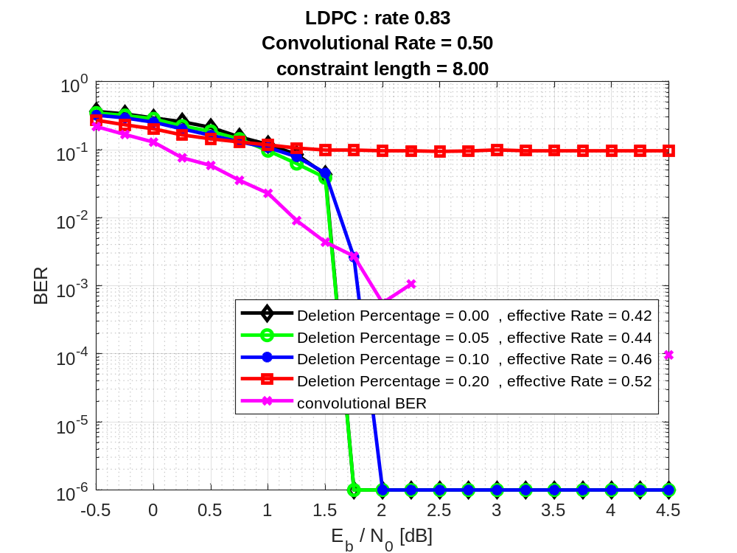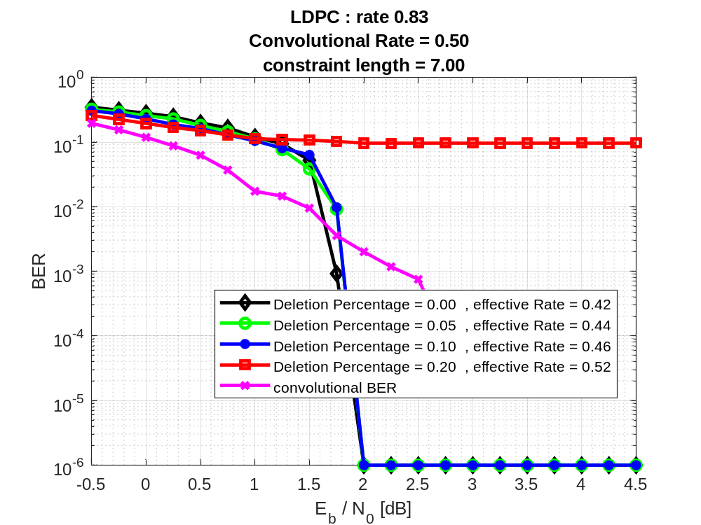

$R_{LDPC}=\frac{3}{4}$
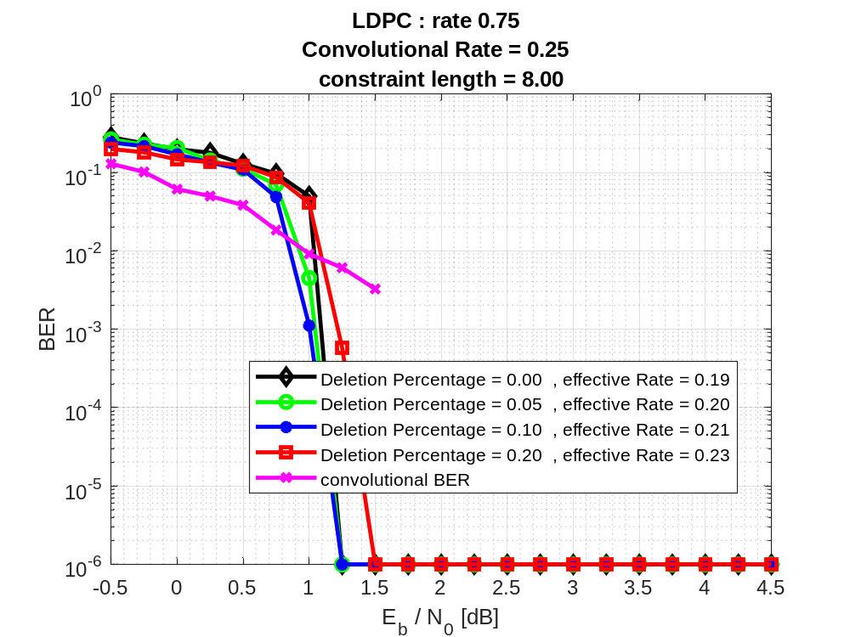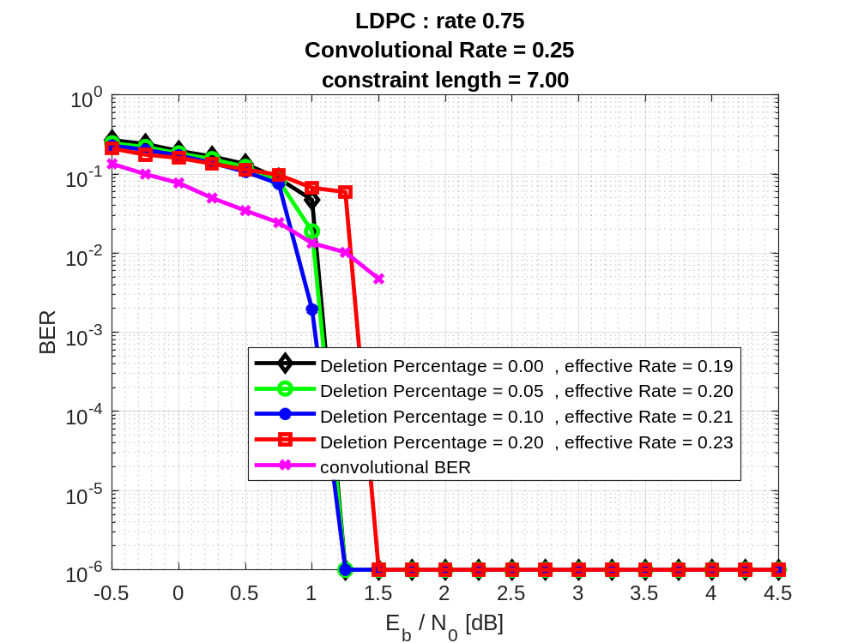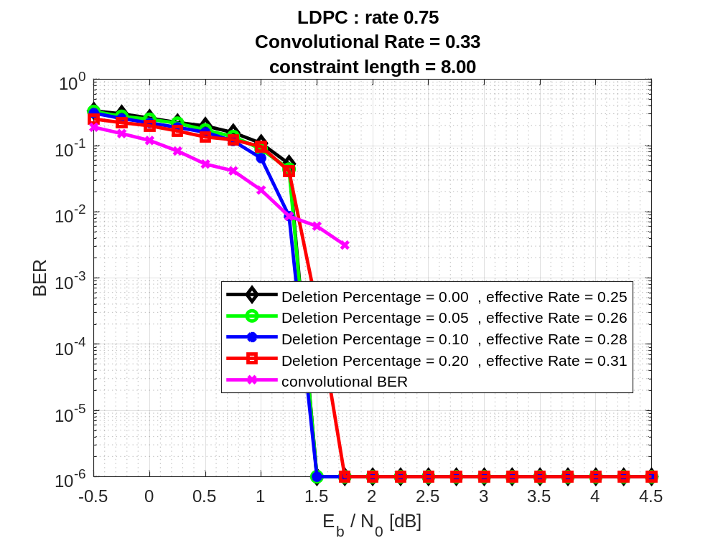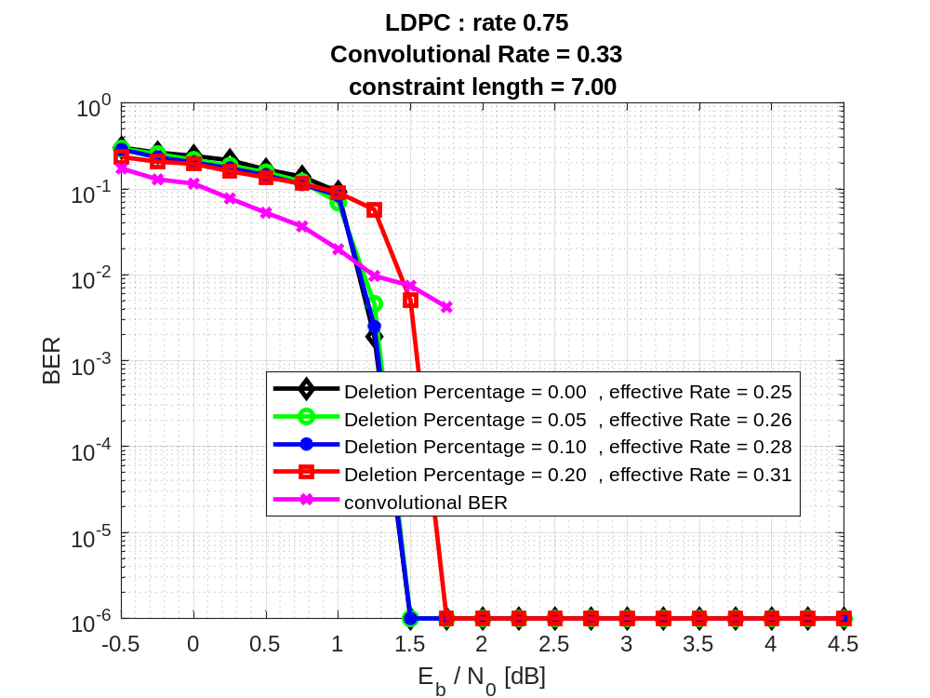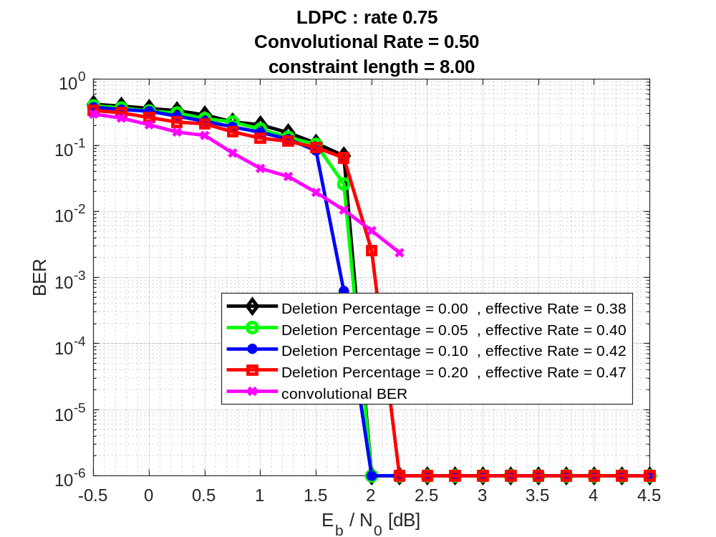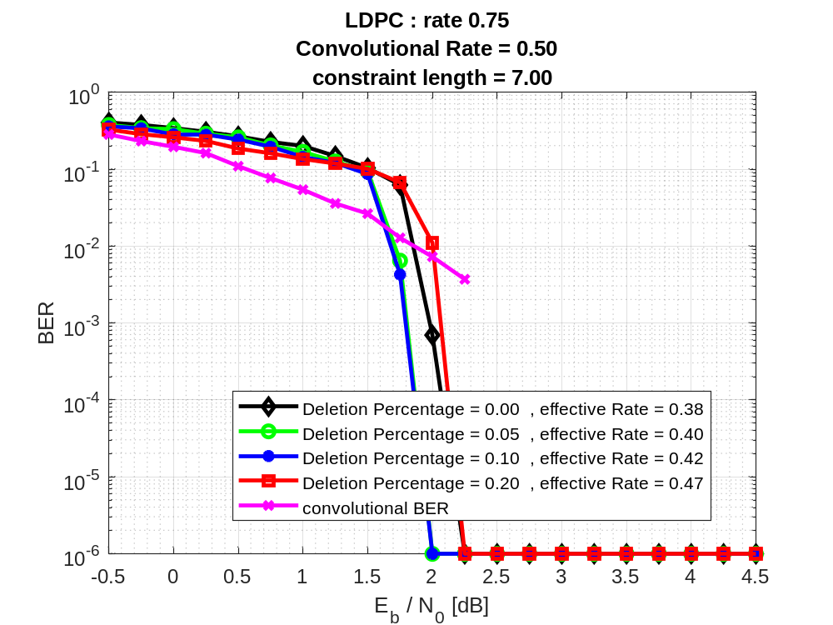

$R_{LDPC}=\frac{2}{3}$
